1. **Branding**

***Logo***

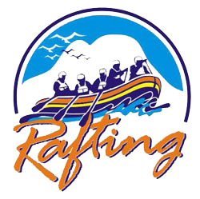

**Style Guide**

1. **Colors**

***Primary-color ------------------- #F1F410***

***Secondary-color --------------- #0592CE***

***Accent1-color ------------------ #291B5E***

***Accent2-color ------------------ #F17912***

1. **Fonts**

***Heading-font ----------------- Josefin Sans***

***Text-font ---------------------- Roboto***

1. **Color Link**

**Color palette URL*:*** [***https://coolors.co/f1f410-0592ce-291b5e-f17912***](https://coolors.co/f1f410-0592ce-291b5e-f17912)